The 148 rows data which is loaded in Organization table on 2017-05-30:
select * from [nbs_odse].[dbo].[Organization]
where add_time >'2017-05-29 15:07:08.390'
and add_time <'2017-05-31 07:07:00.517'
and electronic_ind <>'Y'

The issues for 148 rows data:
- [STATE] column and [STATE_CD] column in [nbs_odse].[dbo].[Organization] table are not populated. The values are ‘NULL’.
We updated [nbs_odse].[dbo].[Organization] table and set [state_cd] as ’VA’. After the ETL run, [STATE_CD] column in the report data source table nbs_odse.dbo.Organization_Line_List values are populated as ‘VA’. As
[STATE] column values should be ‘Virginia’. [STATE_CD] column values should be ‘51’.

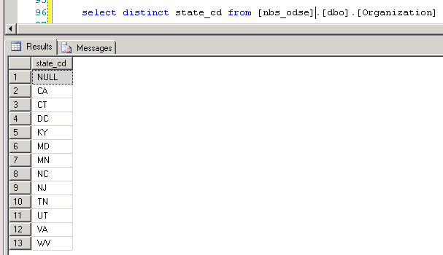
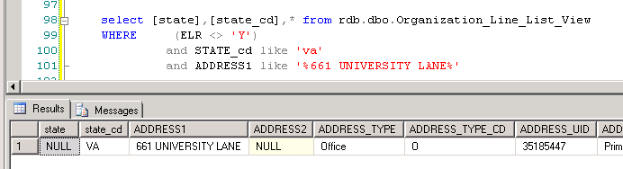

- [Role] Column:
The [Role] Column as Org.Type in the Excel data file are showed as ‘Hemodialysis Unit’.
[cd] column values in [nbs_odse].[dbo].[Role] table for the 148 rows are populated as ‘Hemodialysis Unit’. Does It should be ‘HD’?
[Role] column is not populated in the report and the report data source: [nbs_odse].[dbo].[Organization_Line_List] table.

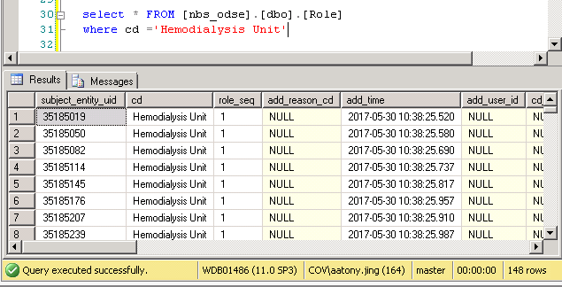
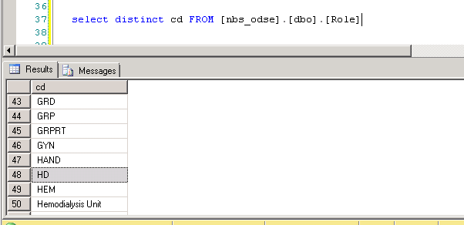

- Organization name:
There are 66 rows data for Disply_name in [nbs_odse]..[organization] like '%davita%'
But there are only 9 rows for ORGANIZATION_NAME in [rdb].[dbo].[D_ORGANIZATION] like '%davita%'.
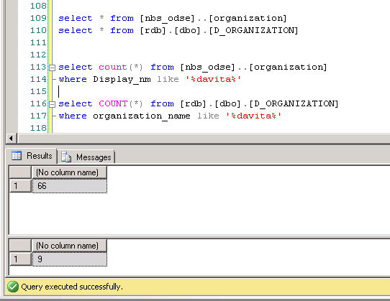

- County and county_cd column for the 148 rows data in line_list table are not populated.
